Gap

Definition
# Source: AI Source: Provided by: [Data Path: Persons Table -> ID Column: 1, Name_En Column: Motasem Essam] -> From: [ChatGPT] on [7/25/2026]
A Gap is a region, space, or interval separating two objects, boundaries, points, lines, or other geometric elements, where the separating space is not occupied by the objects themselves.
In geometry, a gap represents separation or discontinuity between geometric objects.
Important: A gap is not the same as an interval. An interval is a formal mathematical set of numbers, while a gap is the space separating geometric objects.
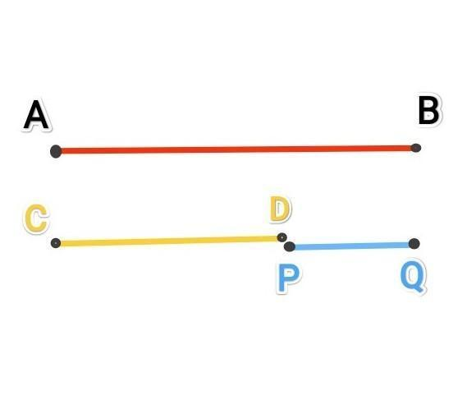
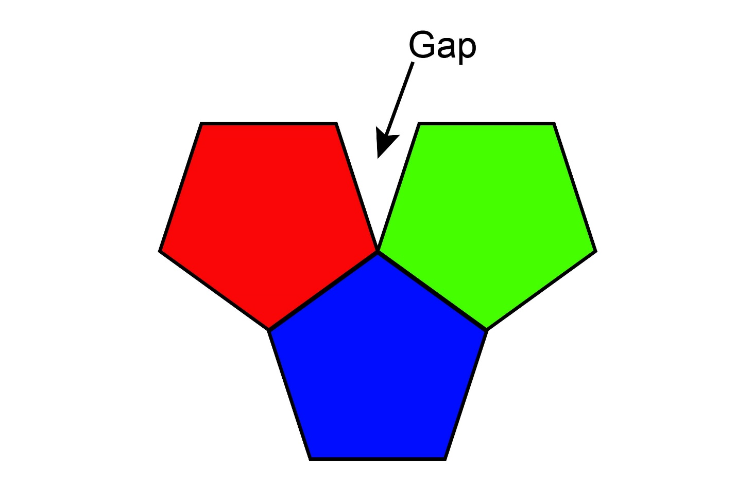
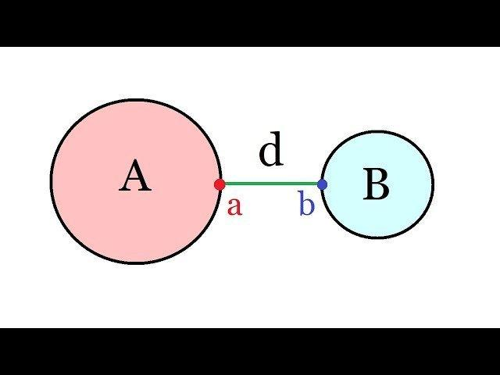
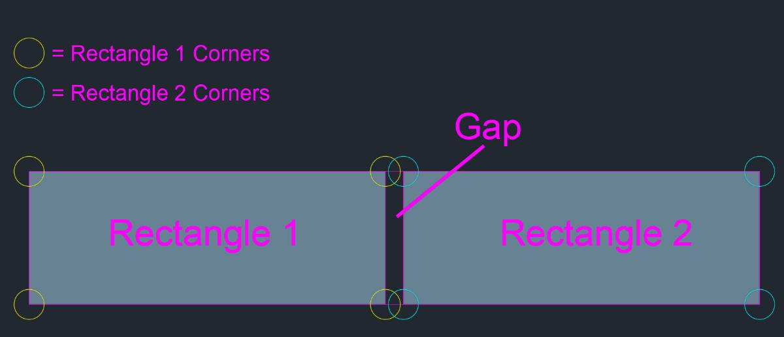
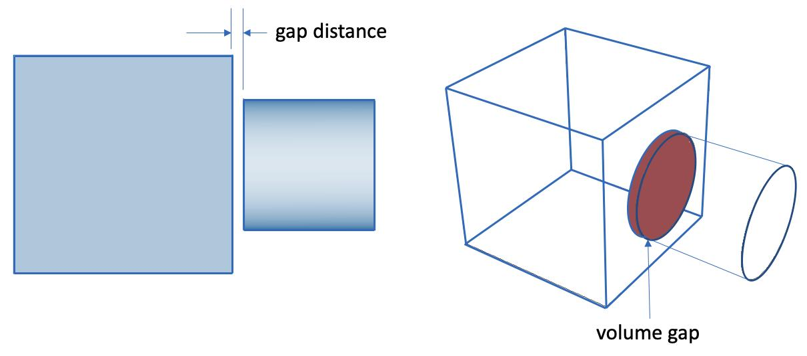

Purpose
# Source: AI Source: Provided by: [Data Path: Persons Table -> ID Column: 1, Name_En Column: Motasem Essam] -> From: [ChatGPT] on [7/25/2026]
The concept of a gap is used to:
- Describe empty space between geometric objects.
- Identify separation between boundaries.
- Distinguish separated objects from touching or overlapping objects.
- Measure the space between objects.
- Analyze clearances, spacing, and discontinuities.

Fundamental Concept
# Source: AI Source: Provided by: [Data Path: Persons Table -> ID Column: 1, Name_En Column: Motasem Essam] -> From: [ChatGPT] on [7/25/2026]
Consider two separated line segments:
A──────B C──────D
← Gap →
The portion between $B$and $C$is the gap.
If the segments lie on the same line, the gap length is:
$$\boxed{g=∣C-B∣}$$
provided $B<C$.
For coordinate points $B\left(x_{1} , y_{1}\right)$and $C\left(x_{2} , y_{2}\right)$, the gap between them is their distance:
$$\boxed{g=\sqrt{{\left(x_{2}-x_{1}\right)}^{2}+{\left(y_{2}-y_{1}\right)}^{2}}}$$

Main Characteristics
# Source: AI Source: Provided by: [Data Path: Persons Table -> ID Column: 1, Name_En Column: Motasem Essam] -> From: [ChatGPT] on [7/25/2026]
A gap may be:
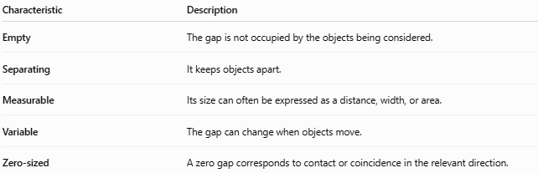
Characteristic | Description
Empty | The gap is not occupied by the objects being considered.
Separating | It keeps objects apart.
Measurable | Its size can often be expressed as a distance, width, or area.
Variable | The gap can change when objects move.
Zero-sized | A zero gap corresponds to contact or coincidence in the relevant direction.

Types of Gaps

1. Point Gap
# Source: AI Source: Provided by: [Data Path: Persons Table -> ID Column: 1, Name_En Column: Motasem Essam] -> From: [ChatGPT] on [7/25/2026]
A separation between two points.
$$g=d\left(A , B\right)$$
Example:
A •────────────• B
Gap

2. Linear Gap
# Source: AI Source: Provided by: [Data Path: Persons Table -> ID Column: 1, Name_En Column: Motasem Essam] -> From: [ChatGPT] on [7/25/2026]
A gap measured along a line or between two collinear objects.
$$\boxed{g=∣x_{2}-x_{1}∣}$$

3. Boundary Gap
# Source: AI Source: Provided by: [Data Path: Persons Table -> ID Column: 1, Name_En Column: Motasem Essam] -> From: [ChatGPT] on [7/25/2026]
The separation between the boundaries of two geometric regions.
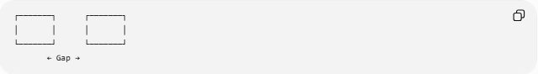
┌───────┐ ┌───────┐
│ │ │ │
└───────┘ └───────┘
← Gap →

4. Region Gap
# Source: AI Source: Provided by: [Data Path: Persons Table -> ID Column: 1, Name_En Column: Motasem Essam] -> From: [ChatGPT] on [7/25/2026]
An empty region separating two or more regions.

5. Surface Gap
# Source: AI Source: Provided by: [Data Path: Persons Table -> ID Column: 1, Name_En Column: Motasem Essam] -> From: [ChatGPT] on [7/25/2026]
In three-dimensional geometry, a separation between surfaces.

6. Clearance Gap
# Source: AI Source: Provided by: [Data Path: Persons Table -> ID Column: 1, Name_En Column: Motasem Essam] -> From: [ChatGPT] on [7/25/2026]
A deliberately maintained minimum separation between objects.
For example, the space between a moving part and a stationary part in a machine.

Gap vs. Distance
# Source: AI Source: Provided by: [Data Path: Persons Table -> ID Column: 1, Name_En Column: Motasem Essam] -> From: [ChatGPT] on [7/25/2026]
A distance is a numerical measure of separation.
A gap describes the separating space itself.
For example:
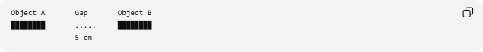
Object A Gap Object B
████████ ..... ████████
5 cm
- Gap → the space between the objects.
- Distance → the measurement of that separation.
- Gap size → $5\text{ cm}$.
Thus:
$$\boxed{\text{Gap is the separated space; distance measures it.}}$$

Gap vs. Separation
# Source: AI Source: Provided by: [Data Path: Persons Table -> ID Column: 1, Name_En Column: Motasem Essam] -> From: [ChatGPT] on [7/25/2026]
Separation is the general geometric relationship in which objects do not touch or intersect.
A gap is the actual space or interval associated with that separation.
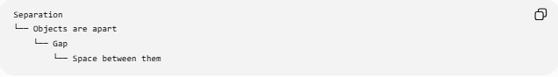
Separation
└── Objects are apart
└── Gap
└── Space between them

Gap vs. Contact
# Source: AI Source: Provided by: [Data Path: Persons Table -> ID Column: 1, Name_En Column: Motasem Essam] -> From: [ChatGPT] on [7/25/2026]
The size of a gap can distinguish separated objects from contacting objects:
$$\boxed{g>0⇒\text{positive gap}} \\ \boxed{g=0⇒\text{contact or coincidence}}$$
For example:
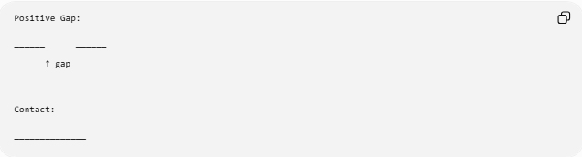
Positive Gap:

────── ──────
↑ gap

Contact:

──────────────

Mathematical Representation
# Source: AI Source: Provided by: [Data Path: Persons Table -> ID Column: 1, Name_En Column: Motasem Essam] -> From: [ChatGPT] on [7/25/2026]
For two closed intervals
$$A=\left[a , b\right]$$
and
$$B=\left[c , d\right]$$
with $b<c$, the gap between them is:
$$\boxed{g=c-b}$$
If $b=c$:
$$g=0$$
and the intervals touch at their common boundary point.
If $b>c$, they overlap, so there is no positive gap between them.

Examples

Example 1: Two Points
# Source: AI Source: Provided by: [Data Path: Persons Table -> ID Column: 1, Name_En Column: Motasem Essam] -> From: [ChatGPT] on [7/25/2026]
If
$$A=\left(2 , 3\right)$$
and
$$B=\left(8 , 3\right)$$
then:
$$g=\sqrt{{\left(8-2\right)}^{2}+{\left(3-3\right)}^{2}} \\ \boxed{g=6}$$

Example 2: Two Collinear Segments
# Source: AI Source: Provided by: [Data Path: Persons Table -> ID Column: 1, Name_En Column: Motasem Essam] -> From: [ChatGPT] on [7/25/2026]
Suppose:
$$AB=\left[0 , 4\right]$$
and
$$CD=\left[9 , 14\right]$$
The gap is:
$$g=9-4 \\ \boxed{g=5}$$

Example 3: Touching Segments
# Source: AI Source: Provided by: [Data Path: Persons Table -> ID Column: 1, Name_En Column: Motasem Essam] -> From: [ChatGPT] on [7/25/2026]
$$AB=\left[0 , 5\right]$$
and
$$CD=\left[5 , 10\right]$$
Then:
$$g=5-5=0$$
Therefore, the segments touch rather than having a positive gap.

Real-World Applications
# Source: AI Source: Provided by: [Data Path: Persons Table -> ID Column: 1, Name_En Column: Motasem Essam] -> From: [ChatGPT] on [7/25/2026]
Gaps are important in:
- Architecture — gaps between buildings and structural components.
- Engineering — mechanical clearances.
- Construction — expansion gaps.
- Manufacturing — tolerances and spacing.
- Roads — gaps between vehicles.
- Computer graphics — spacing between objects.
- Astronomy — separation between celestial objects.
- Cartography — spaces between mapped regions.
- Geometry and CAD — minimum clearance between objects.

Key Points
# Source: AI Source: Provided by: [Data Path: Persons Table -> ID Column: 1, Name_En Column: Motasem Essam] -> From: [ChatGPT] on [7/25/2026]
- A gap is space separating two objects or boundaries.
- It normally implies that the objects are not touching.
- A positive gap has:
$$\boxed{g>0}$$
- A zero gap indicates contact or coincidence in the relevant direction.
- Gap size is commonly measured using distance.
- Gap is closely associated with separation, distance, spacing, and clearance.

